**GMAL**

**(Grant Me A Leave)**

**A Mini-Project Report**

**Under**

**Implementation of Technology**

***Submitted by***

**Khushboo Parasrampuria**

**Jigar Parikh**

**Shreyal Patel**

***Under The Guidance Of***

**Prof. Ratnesh Chaturvedi**

***in partial fulfillment for the award of the degree***

***of***

**Bachelor of Technology**

**IN**

**Computer Engineering**

**at**

**Mukesh patel school of technology management and engineering, nmims**

**APRIL, 2015**

# CERTIFICATE

This is to certify that the project entitled “GMAL (Grant Me A Leave)” is the bonafide work carried out by Khushboo Parasrampuria, Jigar Parikh and Shreyal Patel of B.Tech (Computer Engineering), MPSTME (NMIMS), Mumbai, during the IV semester of the academic year 2014-2015, in partial fulfillment of the requirements for the award of the Degree of Bachelors of Technology as per the norms prescribed by NMIMS. The mini-project work has been assessed and found to be satisfactory.

___________________

Prof. Ratnesh Chaturvedi

_______________________ ________________________

Examiner 1 Examiner 2

________________________

Dean

Dr. Sharad Mhaiskar

# DECLARATION

We, Khushboo Parasrampuria, Jigar Parikh and Shreyal Patel, Roll No. E024, E026 and E028 respectively, of B.Tech (Computer Engineering), IV semester understand that plagiarism is defined as anyone or combination of the following:

1. Un-credited verbatim copying of individual sentences, paragraphs or illustration (such as graphs, diagrams, etc.) from any source, published or unpublished, including the internet.
2. Un-credited improper paraphrasing of pages paragraphs (changing a few words phrases, or rearranging the original sentence order)
3. Credited verbatim copying of a major portion of a paper (or thesis chapter) without clear delineation of who did wrote what. (Source: IEEE, The institute, Dec. 2004)
4. I have made sure that all the ideas, expressions, graphs, diagrams, etc., that are not a result of my work, are properly credited. Long phrases or sentences that had to be used verbatim from published literature have been clearly identified using quotation marks.
5. I affirm that no portion of my work can be considered as plagiarism and I take full responsibility if such a complaint occurs. I understand fully well that the guide of the seminar/ project report may not be in a position to check for the possibility of such incidences of plagiarism in this body of work.

Signature of the Students:

Name: Khushboo Parasrampuria, Jigar Parikh and Shreyal Patel

Roll No. E024, E026 and E028 (respectively)

Place:

Date:

# Acknowledgement

In performing our project, we had to take the help and guideline of some respected persons, who deserve our greatest gratitude. The completion of our project gave us much pleasure. We would like to show our gratitude to Prof. Ratnesh Chaturvedi, Course Instructor, Dr. Dhirendra Mishra, HoD of computer department, and HR, MPSTME for giving us good guideline for our project throughout numerous consultations. We would like to expand our deepest gratitude to all those who have directly or indirectly guided us in completing our app.

We would also like to thank our parents and friends who helped us a lot in finalizing this project within the limited time frame.

# Table of contents

**CHAPTER NO. TITLE PAGE NO.**

List of Figures 6

Abbreviations 7

1. INTRODUCTION 8

1.1 Project Overview 8

1.2 Hardware Specification 8

1.3 Software Specification 10

2. ANALYSIS & DESIGN 11

3. ADVANTAGES & DISADVANTAGES 22

4. FUTURE SCOPE 23

5. CONCLUSION 23

# List of Figures

**CHAPTER NO. TITLE PAGE NO.**

1. INTRODUCTION

Fig1 Splash screen 12

Fig2 Login screen 13

2. Fig3 Faculty inbox 14

Fig4 Leave Form 15

3. Fig5 Leave status Form 16

4. Fig6 HOD Inbox 17

Fig7 Form received 18

5. Fig8. HR inbox 19

Fig9 HR view 20

6. Fig10. Dean login 21

Fig11. Dean inbox 21

*************

# Abbreviations

|  |  |
| --- | --- |
| **Abbreviation** | **Description** |
| ADB | Android Debugging Bridge |
| ADT | Android Development Tools |
| Android SDK | Android Software Development Kit |
| ART | Android Runtime |
| CPU | Central Processing Unit |
| CR | Class Representative |
| GPU | Graphic Processing Unit |
| HoD | Head of Department |
| IPS | In-Plane Switching |
| LCD | Liquid Crystal Display |
| RAM | Random Access Memory |
| SQL | Structured Query Language |
| SR | Student Representative |
| XML | Extensible Markup Language |
| HR | Human Resource |

# Introduction

After Blackboard, going another step towards eco-friendly management. We introduce GMAL.

GMAL i.e. Grant Me a Leave is an application for the faculty of the college, for submitting leave application to their respective Head and Registrar in a more simpler , faster and efficient way. With this application leave database can be more efficiently managed and the faculty can easily keep record of number of leaves taken.

## Project Overview

GMAL is an android application which is built for the faculties of various departments to apply for leave in a faster, easier and efficient manner, without any wastage of resources like time and paper.

It is designed keeping in mind the different levels of access that faculties, HOD’s, Dean, and HR would require. Thus, the applications provides the following logins:

* Staff level – Faculty/staff
* Administrator level –Dean and HoD
* Record - HR

Other than colleges, this can be implemented for a larger community by implementing it for an organization or a company.

## Hardware Specification

GMAL is not a hardware intensive application, thus requires very basic level of hardware, as its application ranges across all devices, low end to high end, phones to tablets. Thus, the following are the minimum hardware specifications required to run the application:

* Processor:
  + 1 GHz ARM Cortex A8 based CPU core
  + PowerVR SGX 540 GPU.
* Memory:
  + 512 MB of RAM
  + 1 GB of Flash Memory
  + Micro-SD card slot (Optional)
* Screen:
  + 3.5-inch LCD display
  + Capacitive or Resistive touch

During Development of the application, RedMi 1S and LG Nexus 4 were used to develop the application on mobiles. Following are the specifications:

* LG Nexus 4:
  + Processor:
    - Quad-core 1.5 GHz Krait Snapdragon APQ8064
    - Adreno 320 GPU
  + Memory:
    - 2GB of RAM
    - 16GB of Flash Memory
  + Screen:
    - 4.7-inch IPS LCD
* RedMi 1S:
  + Processor:
    - 1.5 GHz Qualcomm Snapdragon 401
    - Adreno 330 GPU
  + Memory:
    - 1GB of RAM
    - 8GB of Flash Memory
  + Screen:
    - 5-inch IPS LCD display

## Software Specifications:

GMAL is made on Android SDK API 17, which is primarily for android 4.2 Ice Cream Sandwich. This also has backward compatibility to previous APIs. Classify is designed to work on Android 4.0, Ice Cream Sandwich and above.

Apart from Android 4.0 and above, the application, like most android applications can run on the following Operating Systems:

* Blackberry OS 10.2
* Blackberry OS 11
* Sailfish OS
* Chrome OS
* Color OS
* IUNI OS
* YUN OS
* Nokia X mobile Platform
* Amazon Fire OS
* Tizen OS
* Android x86 (Intel Based devices)
* DuOS-M

Some of these are based on android, while some (BBos 10.2/11, Sailfish OS) are made compatible to run android applications.

Following is the list of Android versions on which GMAL has been tested:

* Android 4.0 (Ice Cream Sandwich)
* Android 4.2 (Jellybean)
* Android 4.3 (Jellybean)
* Android 4.4 (KitKat)
* Android 5.0 (Lollipop)
* Android 5.0.2 (Lollipop)
* Android 5.1 (Lollipop)

This gives the application a broad platform, as these operating systems are in majority of smart phones being used by prospective users.

# Analysis and Design

During the conception of the application, the requirements were mapped out first. This included analyzing the need of this application, its features and figuring out a list of functions it would perform during operation. This largely consisted of the analysis.

A complete analysis was done by discussing with the respective person associated with each level about the procedure for applying leave, sanctioning of the leave and finally record to be maintained. After performing complete analysis, the design of the application was pursued. The design also involved the organization of the GUI and the application’s databases.

## Requirements:

After the discussion with the teachers we discovered:

1. Applying for the leave by submitting the hard copy of the leave form is a very tedious task as the faculty/staff has to seek out the HOD for the submission.
2. The HOD if not present in college cannot receive the application for sanctioning and hence the leave sanctioning will be delayed.
3. The HR is supposed to maintain extension paper work for the database maintenance which can be very complex and often creates difficulties.
4. The website designed for the same can only be accessed when Client PC is connected to local address of the service provider i.e. SVKM WIFI/PSK only.

## Features:

1. Toast notification:

Toast notifications are displayed when login cannot be done, due to incorrect SAP ID or password. Also, while when the leave form is submitted a toast is displayed.

1. Forward to Dean option:

When the HOD receives the form for approval the forward to dean is made optional as it is required by the dean to approve the sanctioning of the leave only in case of emergency or some other reason unlike before.

1. HR level: Load on the HR is reduced as database can be maintained in the sever itself and simply printing of the records can be done for obtaining the hard copy of the same.

## Functions:

**Login:**

On opening the app a splash screen is displayed displaying the logo the application.

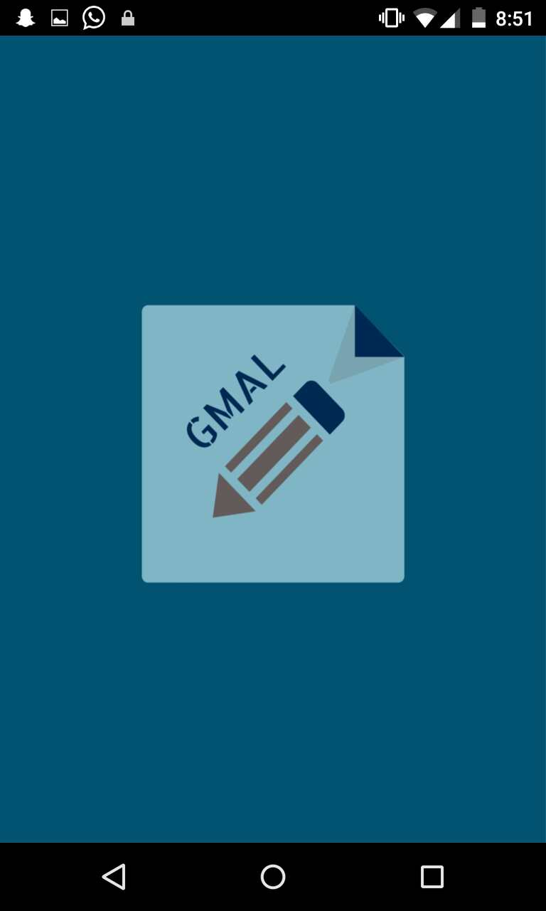

**Fig 1: splash screen**

**Login Screen:**

**A login screen is displayed for the different level according to the user.**

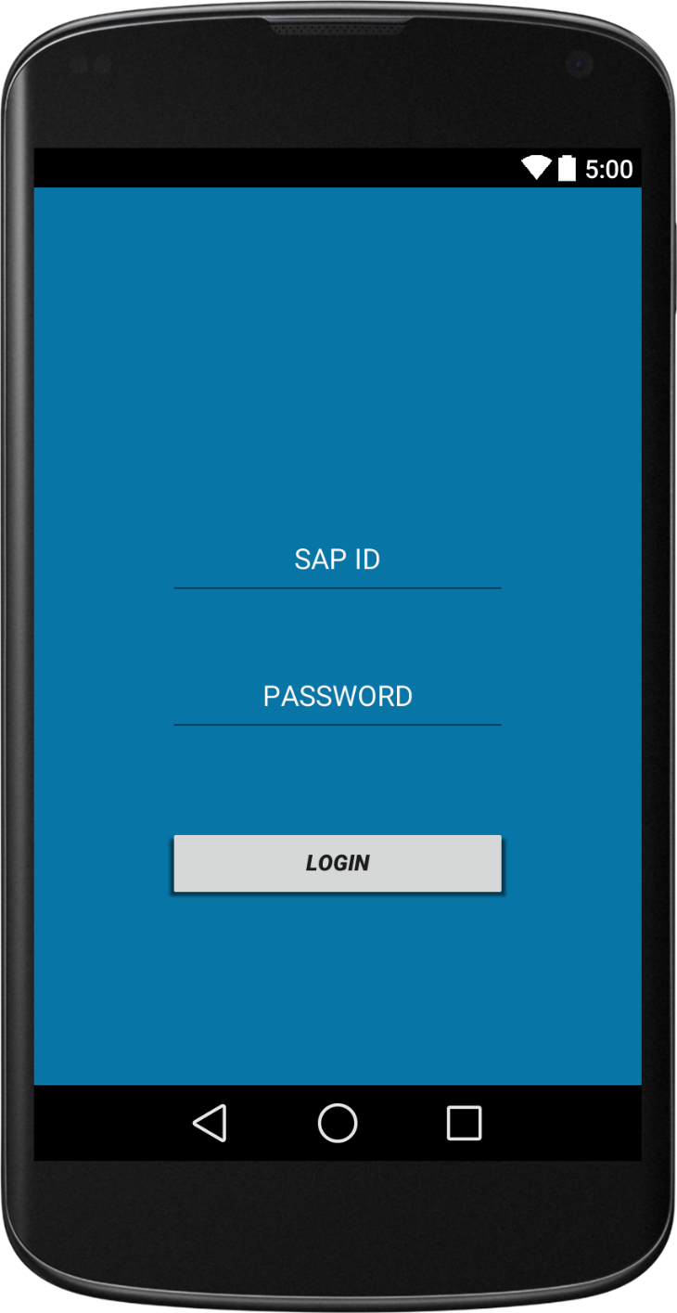

**Fig2: Login Screen**

**Faculty Level:**

The faculty inbox is displayed which contains the leave application applied with the status i.e. whether the application is pending or not. Also, it contains the add button to apply for the leave.

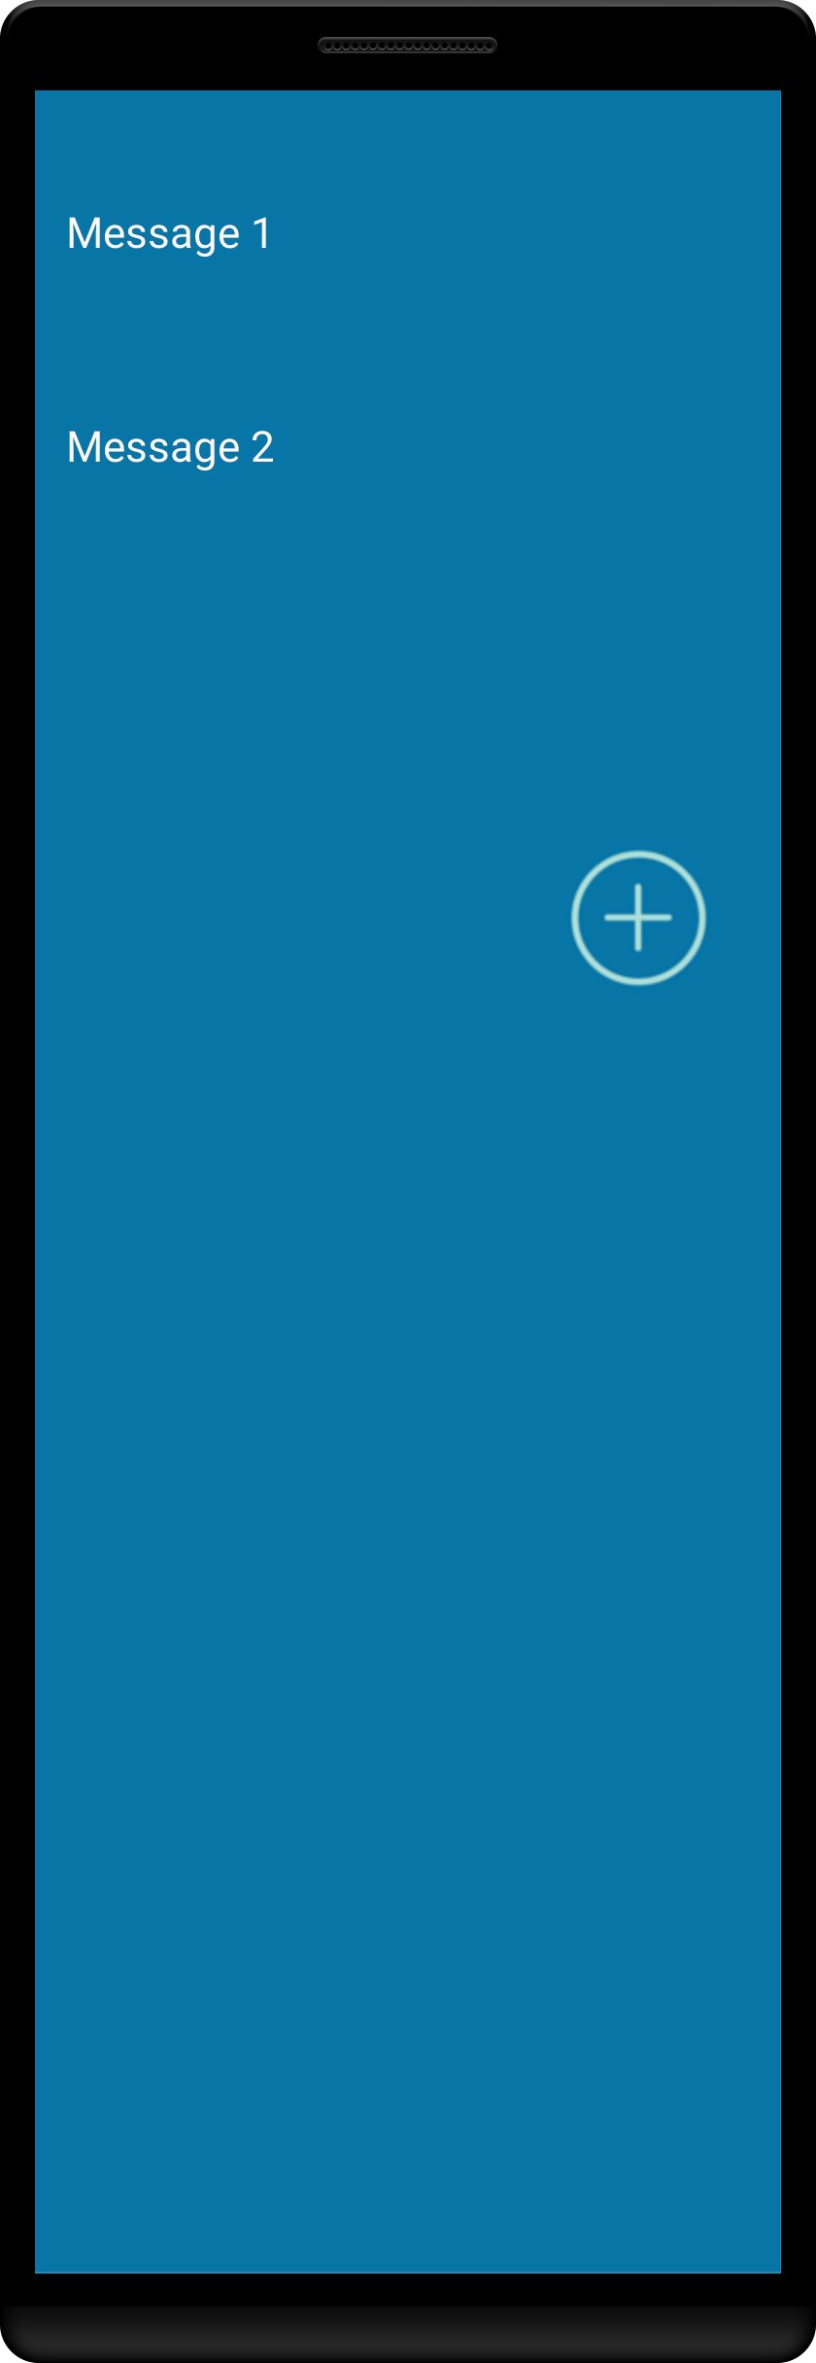

**Fig3: Faculty inbox**

On clicking on the add button, opens the leave form with different mandatory fields along with an option available for attaching the load form.

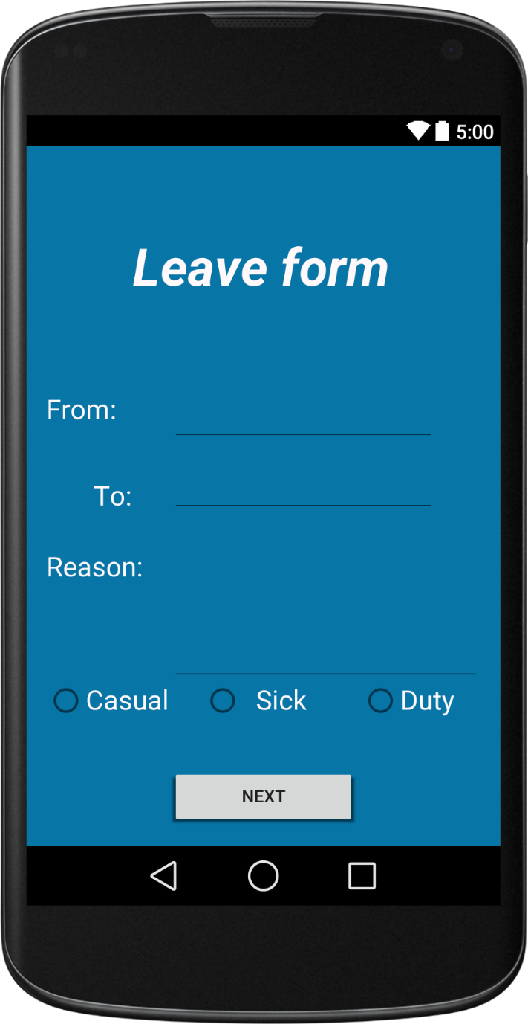

**Fig.4: Leave Form**

After a leave is submitted it can be viewed in the inbox messages to check the status of the leave

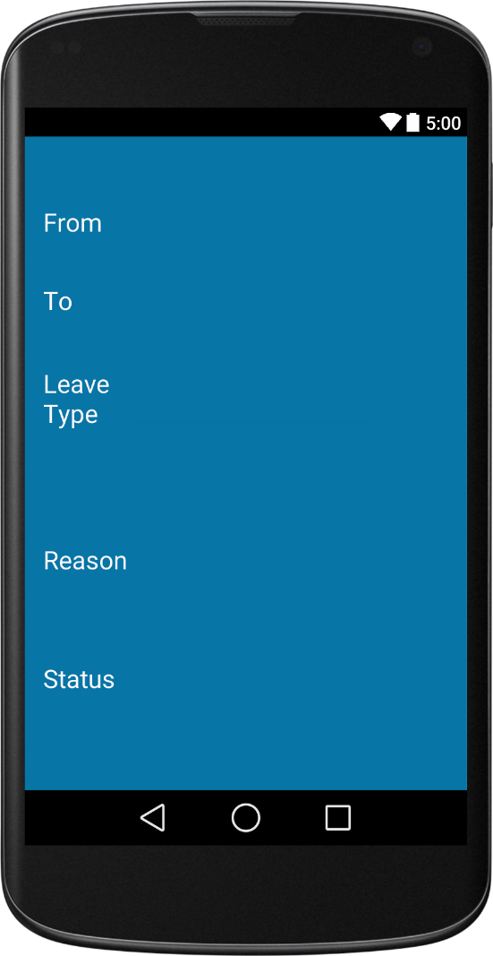

**Fig5: Leave status form**

**HOD Level:**

By logging in the HOD level we get the inbox of the HOD for viewing the application received and also a button for applying leave for himself/herself is given.

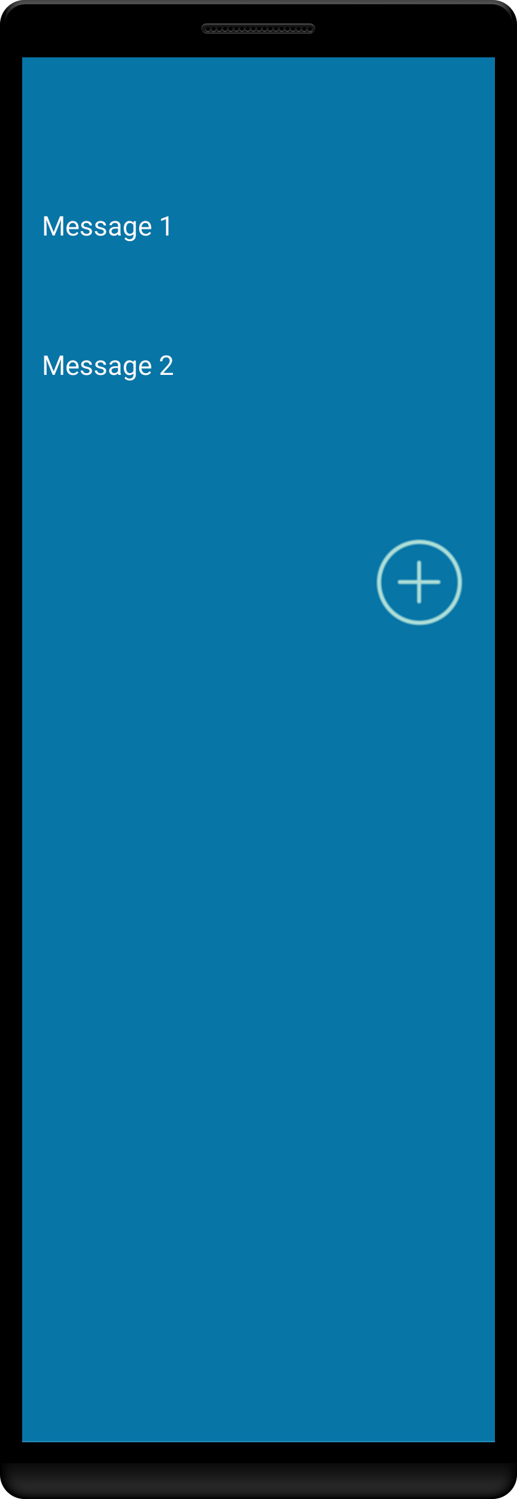

**Fig 6: HOD inbox**

The form received by the HoD is displayed as:

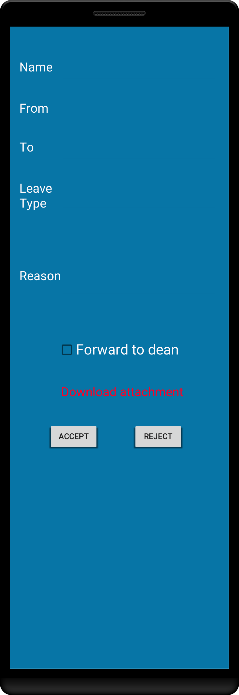

**Fig 7: Form received**

**HR level:**

HR level contains the HR inbox where the leave approved is given.

`

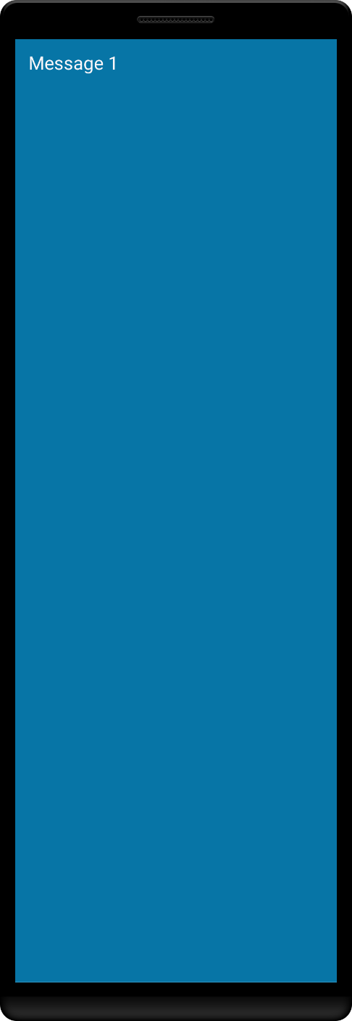

**Fig 8: HR inbox**

Form approved is displayed when clicked on the message received for the record maintenance.

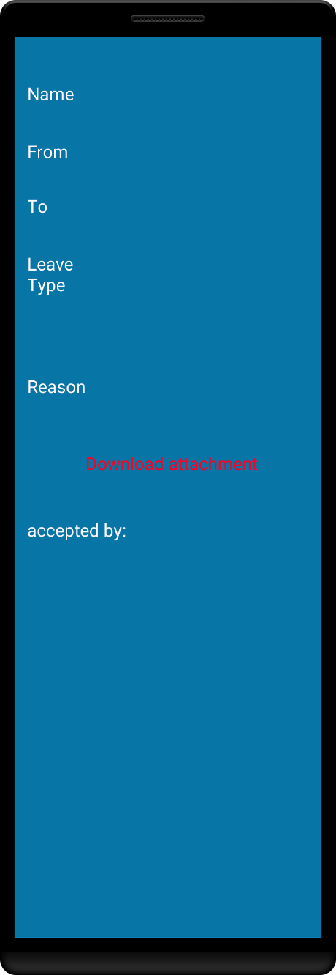

**Fig 9: Form view**

**Dean Level:**

Dean Inbox view to view the leaves if received to for sanction.

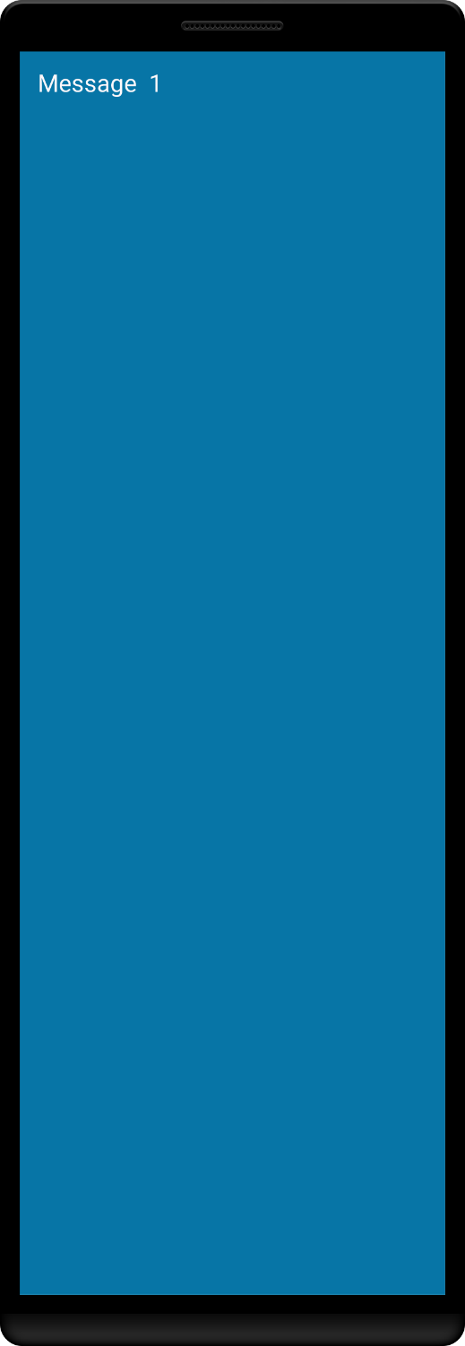

**Fig 10:Dean inbox**

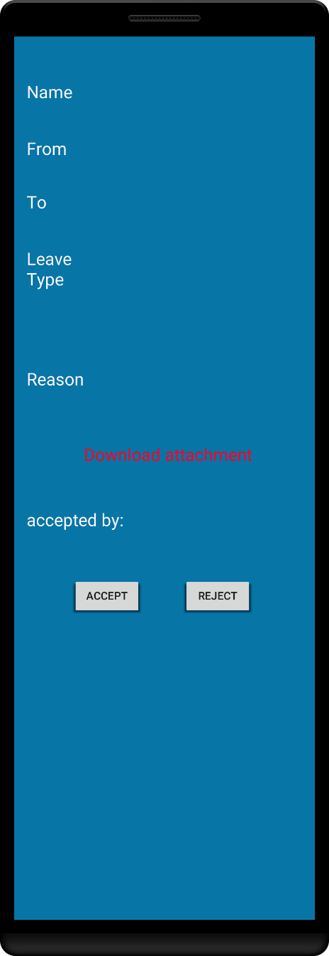

**Fig11: leave form**

**Advantages:**

1. Can apply for leave even outside the college campus unlike the website.
2. Simpler, quicker and easier way to apply for leave.
3. After Blackboard one toward eco-friendly management of data.
4. No need for the faculty/staff to seek the HOD for applying the leave.
5. Extremely useful in emergency cases.

**Disadvantages:**

1. Not everyone uses an android phone.
2. For different institutions we need there servers for there database access.

# Future Scope:

1. Server support will be added.
2. Real time notifications.
3. iOS and Windows application for the same can be designed.
4. Multiple user access will be given.

# Conclusion:

Thus, we successfully implemented our idea for an android app. We have understood the basics of making an android app. We now know how to use android studio for our future endeavours.